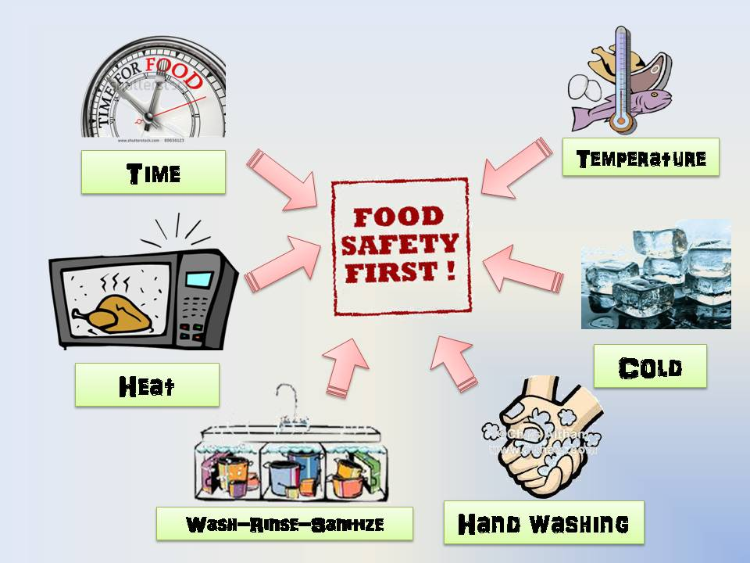`

**Note: The teacher will cut the picture into 8 or 6 pcs and let the students arrange the pieces to form the whole picture**