THREE-DAY SEMINAR-WORKSHOP ON PPST-RPMS ROLL-OUT
May 16 – 18, 2019 @ Liloan Central School
TRAINING MATRIX/SCHEDULE OF ACTIVITIES
CLUSTER 10
TIME | Day 1 (May 16, 2019) | Day 2 (May 17, 2019) | Day 3 (May 18, 2019)
7:00- 8:00 | Arrival | MOL | MOL
8:01-9:00 | Registration  Opening Program  1.Levelling of  Expectations, House Rules,  2. Rationale and  Objectives of the Training,  3. Inspirational Message  Training Team | Session 6  Use of PPST-Based Classroom Observation Tool in the RPMS, COT-RPMS Forms  F1: ALMA A. PIÑEZ  F2: CHERRY C. MALALAY | (Demo-Teaching)  F1: ALMA A. PIÑEZ  F2: CHERRY C. MALALAY
9:01-9:15 | BREAK | BREAK | BREAK
9:16-10:30 | Session 1  BHROD-PPST-RPMS Preliminary for Orientation SY 2019-2020/Context of RPMS  (CSC, DO 2, 42)  F1: CHERRY C. MALALAY  F2: EJENIZA MAREI C. BURABOD | Session 7  COT-RPMS in Portfolio Organization and Assessment  F1: ALMA A. PIÑEZ  F2: CHERRY C. MALALAY | Session 10  PPST Resource Package to Understand the Indicators: Module 2 Walkthrough  F1: BRENDA P. MANGUILIMOTAN  F2: ARMAN A. BOSQUE
10:31-12:00 | Session 2  PPST and Other HR Systems  F1: ARMAN A. BOSQUE  F2: BRENDA P. MANGUILIMOTAN | Continuation of Session 7 | Continuation of Session 10
12:01-1:00 | LUNCH | LUNCH | LUNCH
1:01-2:00 | Session 3  Process of RPMS (RPMS Cycle) Highlighting Roles of Rater and Ratee in Each Phase of the RPMS Cycle  F1: EJENIZA MAREI C. BURABOD  F2: CHERRY C. MALALAY | Session 8  Classroom Observation Protocols *Observers-Pre/During/ Post Observation  *Teachers-Re/During/Post/ Observation  F1: EJENIZA MAREI C. BURABOD  F2: CHERRY C. MALALAY | PPST-RPMS Action Plan Making  F1: ALMA A. PIÑEZ  F2: CHERRY C. MALALAY
2:01-3:00 | Session 4  Understanding the RPMS Tools and MOVs  F1: BRENDA P. MANGUILIMOTAN  F2: ARMAN A. BOSQUE | Session 9  Training Simulations  *Review of Protocols  F1: ARMAN A. BOSQUE  F2: BRENDA P. MANGUILIMOTAN | Portfolio Preparation  F1: ARMAN A. BOSQUE  F2: BRENDA P. MANGUILIMOTAN
3:01-3:15 | BREAK | BREAK | BREAK
3:16-4:30 | Session 5  e-SAT including Data Management and Use of Result, e-SAT Tryout/Discussion of Implementation Issues  F1: CHERRY C. MALALAY  F2: EJENIZA MAREI C. BURABOD | Continuation of Session 9 | Closing Program  Impressions  Challenge  Inspirational Talk  Response  Pledge of Commitment  Distribution of Certificates of  Attendance/Participation  Closing Remarks  Training Team/MOL
4:31-5:00 | Reflection of the Day | Reflection of the Day | Reflection of the Day
OD | ARMAN A. BOSQUE | ARMAN A. BOSQUE | BRENDA P. MANGUILIMOTAN
Documenter | EJENIZA MAREI C. BURABOD | EJENIZA MAREI C. BURABOD | EJENIZA MAREI C. BURABOD
Secretariat | BRENDA P. MANGUILIMOTAN | ALMA A. PIÑEZ | ALMA A. PIÑEZ
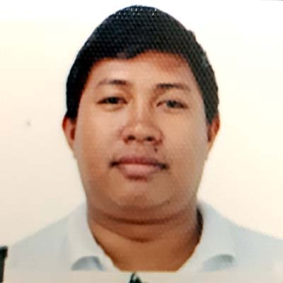
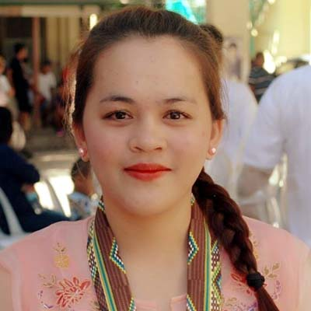
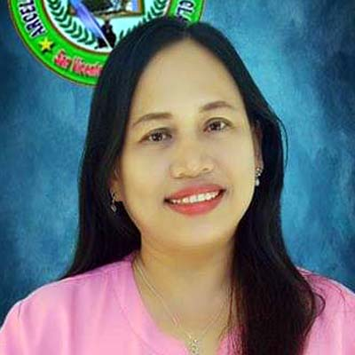
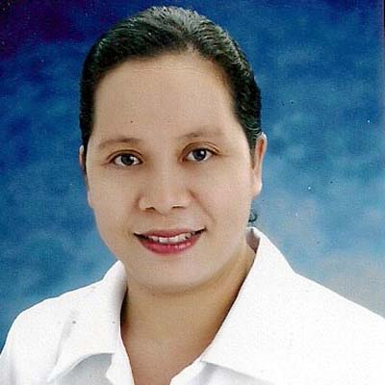
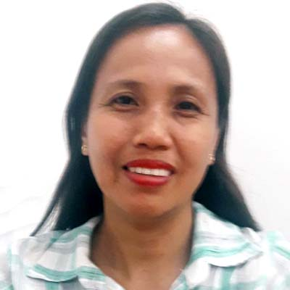
Prepared by:
CARMELITO M. LAURON SR.
Training Manager

