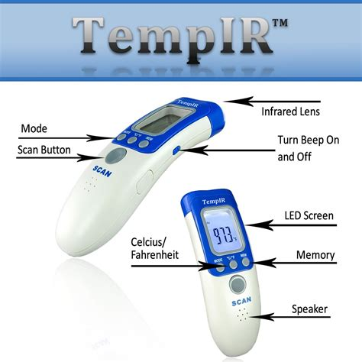

- Mode
- Scan Button
- Infrared Lens
- Turn Beep On and Off
- Celcius/Fahenheit
- LED Screen
- Memory
- Speaker

