Republic of the Philippines
Department of Education
Region VII, Central Visayas
Division of Cebu Province
District of Lilo-an

CERTIFICATE OF APPEARANCE

This is to certify that

Cherry Malalay
________________________________________________

has personally appeared at Lilo-an Central School, Poblacion Lilo-an Cebu this
16-18th day of May 2019 during the ROLL-OUT of RPMS PPST.

Given this 18th day of May 2019 at Lilo-an Central School, Poblacion Lilo-an Cebu.

MARYLUZ T. ALISER MARIA TERESA G. SINGURAN
District HRD/ L & D Focal Person District Caretaker

Republic of the Philippines
Department of Education
Region VII, Central Visayas
Division of Cebu Province
District of Lilo-an

CERTIFICATE OF APPEARANCE

This is to certify that
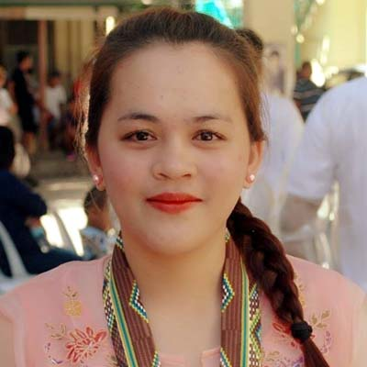

Ejeniza Marei Cabanes Burabod
________________________________________________

has personally appeared at Lilo-an Central School, Poblacion Lilo-an Cebu this
16-18th day of May 2019 during the ROLL-OUT of RPMS PPST.

Given this 18th day of May 2019 at Lilo-an Central School, Poblacion Lilo-an Cebu.

MARYLUZ T. ALISER MARIA TERESA G. SINGURAN
District HRD/ L & D Focal Person District Caretaker

