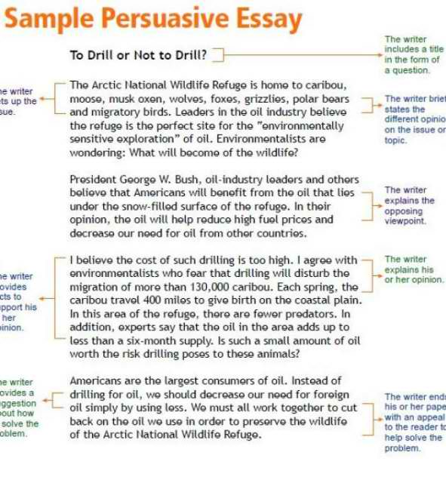

Should Marine Mammals Be in Captivity?
http://teacher.scholastic.com/dolphin/conwin1.htm
Sharon Banta
In my opinion there is no doubt that marine mammals should NOT be held in captivity. Marine mammals are a part of nature and should not be bought, sold or thrown in an aquarium. I believe that they have the right to be kept in their natural environment.
I have many convincing reasons to support my opinion. Captivity causes many health problems in marine mammals. Many tanks have water full of chemicals and bacteria; this results in blindness and many skin problems in dolphins and other marine mammals. Marine mammals in captivity die from pneumonia, ulcers and other stress-related diseases. Most of these helpless creatures suffer from boredom. Dolphins in the wild can swim up to 40–100 miles per day but in pools they go around swimming in repetitive patterns. Due to boredom and limited space many dolphins abuse themselves; they often bang their heads against tank and aquarium walls. Some of these poor innocent creatures face abusive treatment by their caretakers, thus shortening their life span. In fact Keiko, the killer whale, the star of Free Willy, was a victim of this type of abuse. It was known to be said that he was 1,000 pounds underweight and developed a wart-like disease. His teeth were ground down from chewing the sides of the pool due to boredom and he had a problem with his dorsal fin. Marine mammals breed very poorly in captivity with very high infant death rates. For this reason, when a baby dolphin is born into captivity its birth is usually kept a secret from its mother until it shows signs of survival. Marine mammals do breed in captivity, but the birth rate in captivity is not as successful as in the wild.
Many people think that marine mammals should remain in captivity. I realize that some people may believe that captivity increases the life span of certain animals, but the truth is if these creatures are so happy in captivity, why do they die so fast? Captivity shortens animal life spans, not increases them. Wild dolphins can live 40 years in the wild and orcas can live 90 years, but when held in captivity they rarely survive their teens. Twenty-three out of 25 orcas have died in captivity. Some people think that holding animals in captivity helps with study and research. But the truth is scientists prefer to learn about animals in their natural environment so they get firsthand knowledge.
In conclusion, I think marine mammals should definitely not be held in captivity. I think Ghandi said it best when he mentioned, "The greatness of a nation and its moral process can be measured by the way its animals are treated." In a world where much of nature and the wild has already been lost to us, it is up to us to let these beautiful marine mammals free.

